# PRACTICAL NO: 01

**Aim:** To verify Career mate’s functionality using structured manual testing techniques.

|  |  |  |  |  |  |  |  |  |
| --- | --- | --- | --- | --- | --- | --- | --- | --- |
| **Sr. No** | **Test ID** | **Action** | **Description** | **Input** | **Expected Output** | **Actual Output** | **Test Result** | **Test Comment** |
| 1 | register_01 | User Registration | Test new user sign-up flow | Valid username, email, password | Account should be created and should redirect to dashboard/login | Success message is shown | Pass | Working as expected |
| 2 | register_02 | Duplicate Registration | Check for duplicate email during registration | Already registered email | System should show “Email already exists” error | Error message is shown | Pass | Validation enforced |
| 3 | login_01 | Login with valid credentials | Authenticate with correct credentials | Correct email and password | System should redirect to dashboard | User is redirected successfully | Pass | Login successful |
| 4 | login_02 | Login with invalid credentials | Block incorrect login attempts | Wrong password | System should show “Incorrect credentials” error | Error message is shown | Pass | Login validation working |
| 5 | login_03 | Forgot Password | Test password recovery process | Registered email address | System should display reset instructions or should send reset email | Message is shown | Pass | Flow implemented correctly |
| 6 | login_04 | Logout | Verify logout clears session | Click logout button | System should redirect to login page | Logout is successful | Pass | Session cleared |
| 7 | job_01 | View Jobs | Display job listings after login | Click “Jobs” tab | System should show available job listings | Listings are visible | Pass | Display correct |
| 8 | job_02 | Search Jobs | Verify job search/filter works | Search keyword (e.g., React Developer) | Filtered job list should be shown | Filter results are accurate | Pass | Search functional |
| 9 | job_03 | Apply to Job | Apply to selected job | Click “Apply” | System should show confirmation message or should move to “Applied” section | Confirmation is shown | Pass | Apply logic verified |
| 10 | resume_01 | Upload Resume with valid file | Upload a valid resume file | Upload PDF file | System should show “Resume uploaded successfully” | Upload is successful | Pass | Functional |
| 11 | resume_02 | Upload Resume with invalid file | Prevent upload of unsupported file types | Upload .exe, .js file | System should show “Invalid file type” error | Error message is shown | Pass | Security check passed |
| 12 | profile_01 | Update Profile | Edit user details and save | Change name, skills, contact info | Updated profile should be displayed | Changes are saved | Pass | Update working |
| 13 | security_01 | Unauthorized Dashboard Access | Prevent access without login | Visit dashboard URL without login | System should redirect to login page | Redirect is successful | Pass | Access control functional |
| 14 | uiux_01 | Mobile View | Check layout responsiveness | Open in mobile browser/emulator | Layout should adjust without breaking | Responsive layout is visible | Pass | Mobile-friendly verified |
| 15 | admin_01 | Admin Login | Admin authentication with correct credentials | Valid admin login | System should redirect to admin dashboard | Admin is logged in | Pass | Admin role verified |
| 16 | admin_02 | Admin Adds Job | Test job posting via admin panel | Fill job form and submit | Job should appear in job listings | Job is listed | Pass | Create functionality works |
| 17 | admin_03 | Admin Deletes Job | Remove a job posting from system | Click delete on a job | Job should be deleted from DB and UI | Job is removed | Pass | Delete logic confirmed |

# PRACTICAL NO: 02

**Aim:** Implement web drivers on chrome and Firefoxbrowser(chrome, Firefox,choose browser)

1. **Chrome**

**package** com.gh;

**import**org.openqa.selenium.WebDriver;

**import**org.openqa.selenium.firefox.FirefoxDriver;

**publicclass** l {

**publicstaticvoid** main(String[] args) {

System.*setProperty*("webdriver.chrome.driver","C:\\selenium web driver\\ChromeDriver\\chromedriver-win64\\chromedriver-win64\\geckodriver.exe");

WebDriverwd = **new**FirefoxDriver();

wd.get("http://google.com");

}

}

OUTPUT:

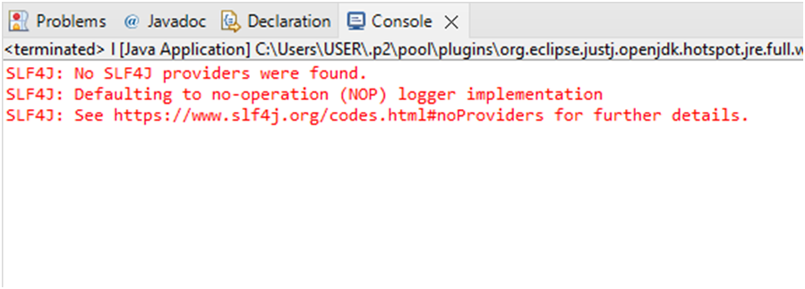

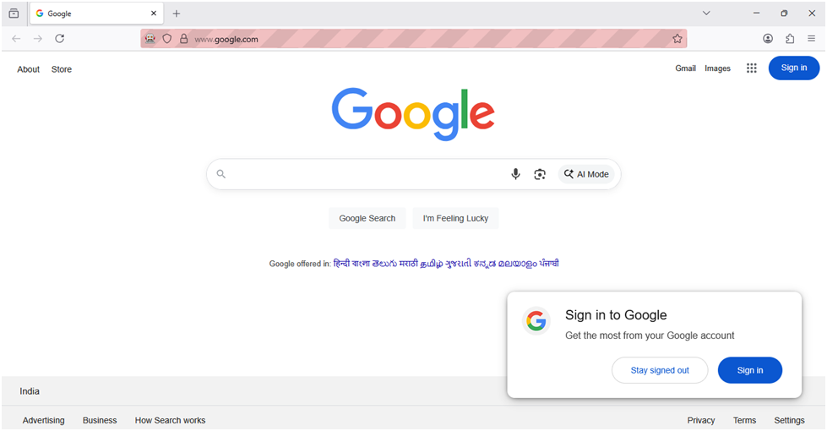

1. **FireFox**

package com.prac2;

import org.openqa.selenium.WebDriver;

import org.openqa.selenium.firefox.FirefoxDriver;

public class Practical2 {

public static void main(String[] args) {

System.setProperty("webdriver.chrome.driver","C:\\selenium webdriver\\ChromeDriver\\chromedriver-win64\\chromedriver-win64\\geckodriver.exe");

WebDriver wd = new FirefoxDriver();

wd.get("http://netlify.com");

}

}

OUTPUT:

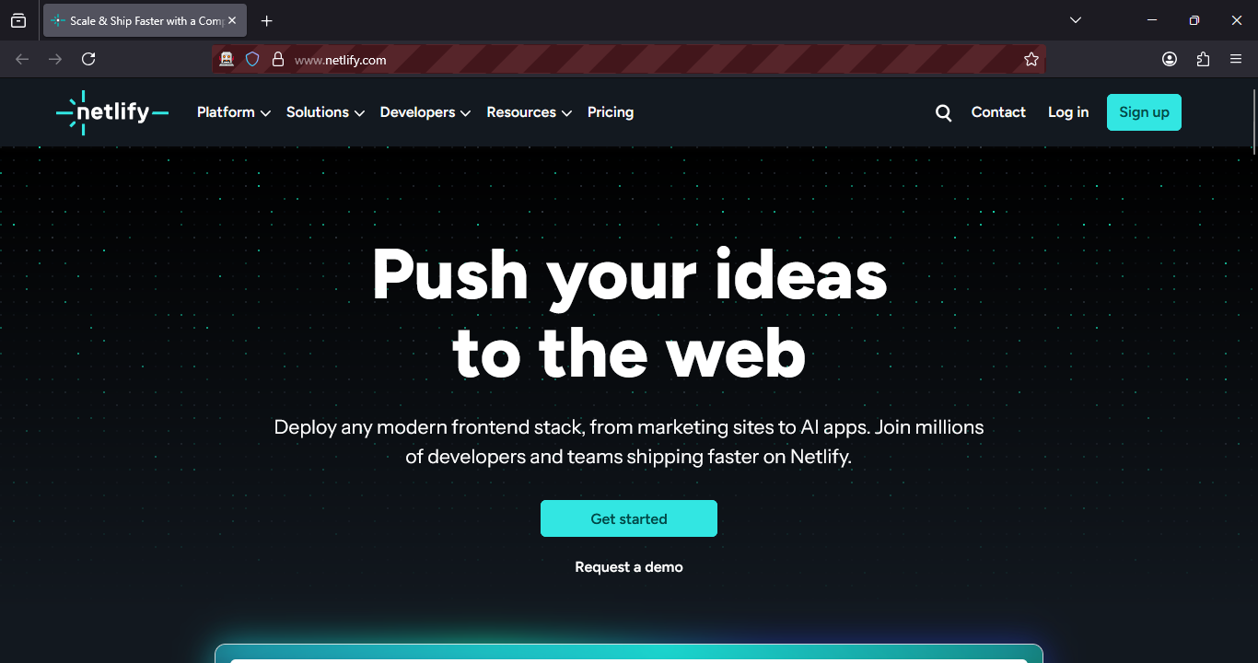

1. **Any Browser**

**package**prati;

**import**java.util.Scanner;

**import**org.openqa.selenium.WebDriver;

**import**org.openqa.selenium.chrome.ChromeDriver;

**import**org.openqa.selenium.firefox.FirefoxDriver;

**publicclass** Browser {

**static**WebDriver*wd*;

**publicstaticvoid** main(String[] args) {

Scanner sc = **new**Scanner(System.***in***);

System.***out***.println("Welcome");

System.***out***.println("1.Chrome\n2.Firefox\n");

System.***out***.println("Choice");

**int**ch = sc.nextInt();

sc.close();

**switch**(ch)

{

**case** 1:

System.*setProperty*("webdriver.chrome.driver","C:\\selenium web driver\\ChromeDriver\\chromedriver-win64\\chromedriver-win64\\chromedriver.exe");

*wd* = **new**ChromeDriver();

**break**;

**case** 2:

System.*setProperty*("webdriver.chrome.driver","C:\\selenium web driver\\ChromeDriver\\chromedriver-win64\\chromedriver-win64\\geckodriver.exe");

*wd* = **new**FirefoxDriver();

**break**;

**default**:System.***out***.println("Invalid Choice");

}

**if**(*wd* !=**null**)

{

*wd*.get("http://figma.com"); }}

}

OUTPUT:

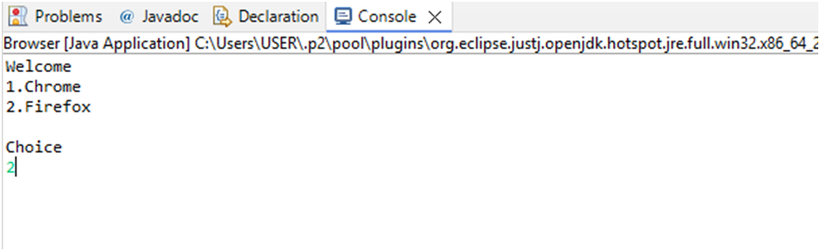

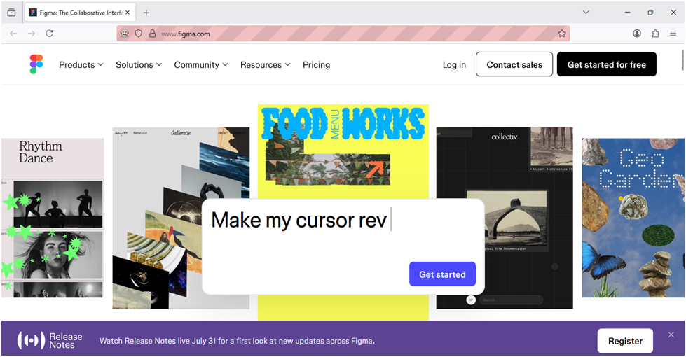

# PRACTICAL NO: 03

**Aim:** Demonstrate wait command in selenium.

|  |
| --- |
| package JavaPracticals;  import org.openqa.selenium.By;  import org.openqa.selenium.WebDriver;  import org.openqa.selenium.firefox.FirefoxDriver;  import org.openqa.selenium.support.ui.Select;  import org.openqa.selenium.support.ui.WebDriverWait;  import org.openqa.selenium.support.ui.ExpectedConditions;  import java.time.Duration;  public class OrderPlace {  public static void main(String[] args) {  System.setProperty("webdriver.gecko.driver",  "C:\\selenium web driver\\ChromeDriver\\chromedriver-win64\\geckodriver.exe");  WebDriver wd = new FirefoxDriver();  wd.get("https://demo.frontaccounting.eu/");  WebDriverWait wait = new WebDriverWait(wd, Duration.ofSeconds(10));  wait.until(ExpectedConditions.visibilityOfElementLocated(  By.name("user_name_entry_field"))).sendKeys("your_username");  wait.until(ExpectedConditions.visibilityOfElementLocated(  By.name("password"))).sendKeys("your_password");  Select companySelect = new Select(wd.findElement(By.name("company_login_name")));  wd.findElement(By.name("SubmitUser")).click();  wait.until(ExpectedConditions.elementToBeClickable(By.xpath( "/html/body/table[1]/tbody/tr/td/table[1]/tbody/tr/td/div[2]/table/tbody/tr[1]/td/table/tbody/tr[2]/td[1]/a[1]"  ))).click();  Select customerSelect = new Select(wd.findElement(By.name("customer_id")));  customerSelect.selectByVisibleText("Donald Easter");  wd.findElement(By.name("AddItem")).click();  wd.findElement(By.name("ProcessOrder")).click();  wd.quit();  }  } |

OUTPUT:

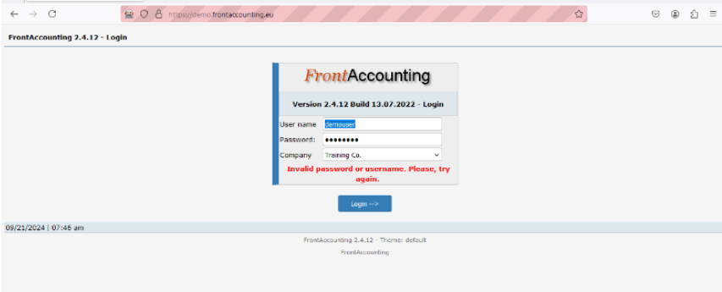

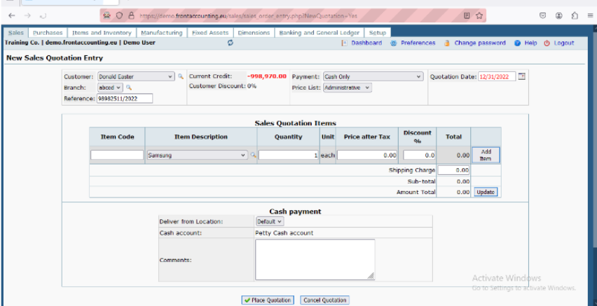

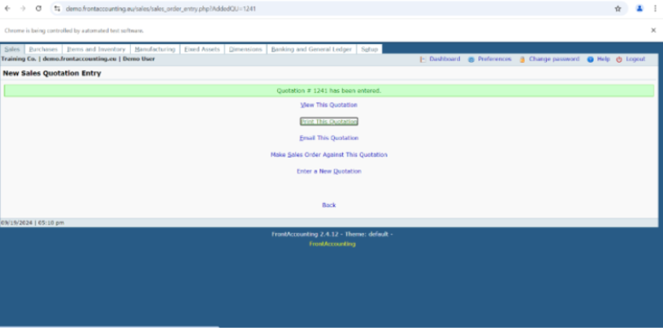

# PRACTICAL NO: 04

**Aim:** Implement Browser command and navigation commands

|  |
| --- |
| package com.prac4;  import org.openqa.selenium.By;  import org.openqa.selenium.WebDriver;  import org.openqa.selenium.firefox.FirefoxDriver;  public class Prac4 {    public static void main(String[] args) throws Exception  {  System.setProperty("webdriver.chrome.driver","C:\\selenium web driver\\ChromeDriver\\chromedriver-win64\\chromedriver-win64\\geckodriver.exe");  WebDriver wd = new FirefoxDriver();  wd.get("https://opensource-demo.orangehrmlive.com/");  Thread.sleep(3000);  wd.findElement(By.name("username")).sendKeys("admin");  wd.findElement(By.name("password")).sendKeys("admin123");  wd.findElement(By.xpath("//*[@id=\"app\"]/div[1]/div/div[1]/div/div[2]/div[2]/form/div[3]/button")).click();  Thread.sleep(2000);  wd.navigate().back();  Thread.sleep(2000);  wd.navigate().forward();  wd.navigate().to("https://opensource-demo.orangehrmlive.com/");  wd.navigate().refresh();  }  } |

OUTPUT:

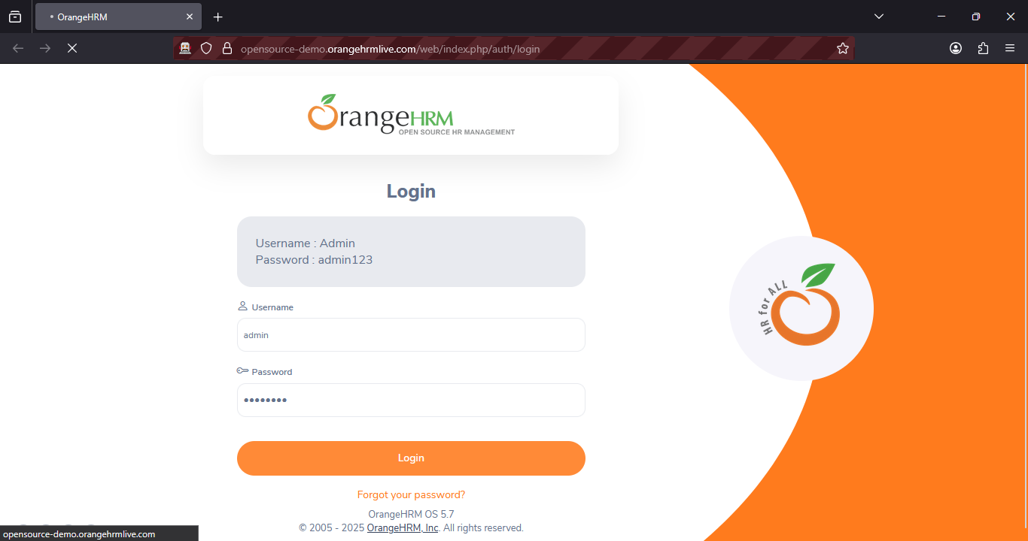

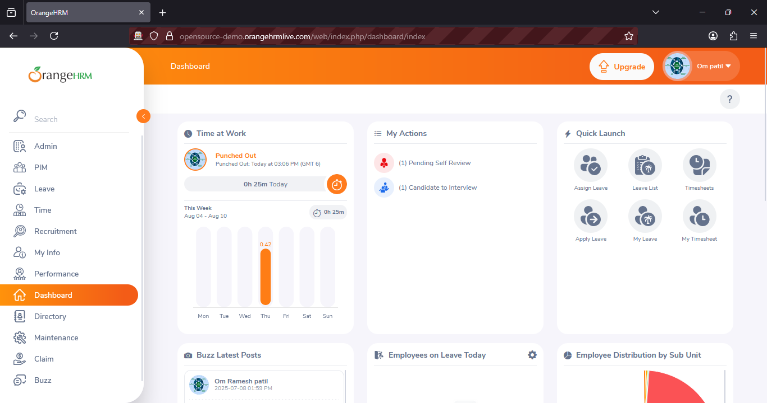

# PRACTICAL NO: 05

**Aim:** Implement the find element command.

|  |
| --- |
| package com.prac5;  import org.openqa.selenium.By;  import org.openqa.selenium.WebDriver;  import org.openqa.selenium.firefox.FirefoxDriver;  public class Practical5 {  public static void main(String[] args) throws Exception  {  System.setProperty("webdriver.chrome.driver","C:\\selenium web driver\\ChromeDriver\\chromedriver-win64\\chromedriver-win64\\geckodriver.exe");  WebDriver wd = new FirefoxDriver();  wd.get("https://opensource-demo.orangehrmlive.com/");  Thread.sleep(5000);  wd.findElement(By.xpath("/html/body/div/div[1]/div/div[1]/div/div[2]/div[2]/form/div[1]/div/div[2]/input")).sendKeys("admin");  wd.findElement(By.xpath("/html/body/div/div[1]/div/div[1]/div/div[2]/div[2]/form/div[2]/div/div[2]/input")).sendKeys("admin123");  wd.findElement(By.xpath("/html/body/div/div[1]/div/div[1]/div/div[2]/div[2]/form/div[3]/button")).click();  }  } |

OUTPUT:





# PRACTICAL NO: 06

**Aim:** Demonstrate the locator(CSS Selector,Xpath,path)

1) cssSelector

|  |
| --- |
| **package** JavaPracticals;  **import** org.openqa.selenium.By;  **import** org.openqa.selenium.WebDriver;  **import** org.openqa.selenium.firefox.FirefoxDriver;  **public** **class** CssSelector {  **public** **static** **void** main(String[] args) **throws** Exception {  System.*setProperty*("webdriver.gecko.driver", "C:\\selenium web driver\\ChromeDriver\\chromedriver-win64\\chromedriver-win64\\geckodriver.exe");    WebDriver wd = **new** FirefoxDriver();  wd.get("https://opensource-demo.orangehrmlive.com/");    Thread.*sleep*(2000);  wd.findElement(By.*cssSelector*("input[name='username']")).sendKeys("admin");  wd.findElement(By.*cssSelector*("input[name='password']")).sendKeys("admin123");  wd.findElement(By.*cssSelector*("button[type='submit']")).click();  }  } |

OUTPUT:

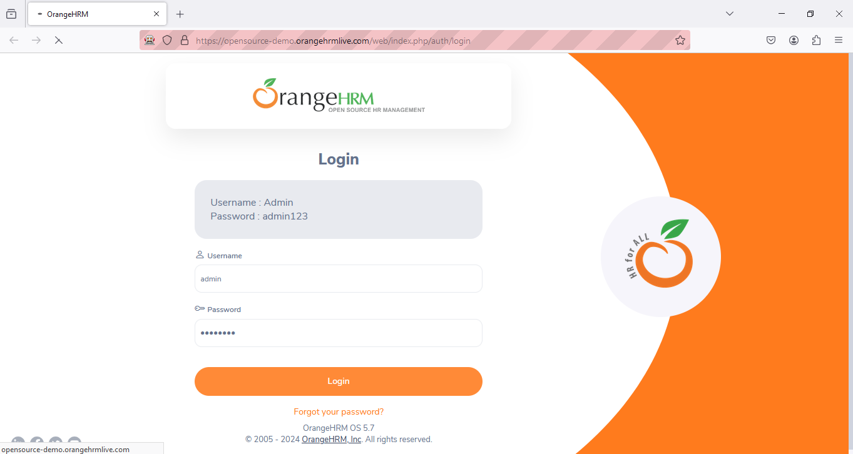

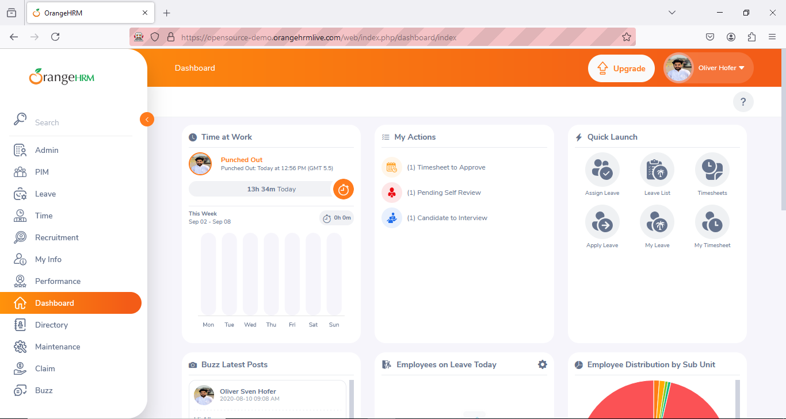

**2) XPath**

|  |
| --- |
| package JavaPracticals;  import org.openqa.selenium.By;  import org.openqa.selenium.WebDriver;  import org.openqa.selenium.firefox.FirefoxDriver;  public class Practical4 {  public static void main(String[] args) throws Exception {  System.setProperty(  "webdriver.gecko.driver",  "C:\\selenium web driver\\ChromeDriver\\chromedriver-win64\\chromedriver-win64\\geckodriver.exe"  );  WebDriver wd = new FirefoxDriver();  wd.get("https://opensource-demo.orangehrmlive.com/");  Thread.sleep(5000);  wd.findElement(By.xpath("/html/body/div/div[1]/div/div[1]/div/div[2]/div[2]/form/div[1]/div/div[2]/input")).sendKeys("admin");  wd.findElement(By.xpath("/html/body/div/div[1]/div/div[1]/div/div[2]/div[2]/form/div[2]/div/div[2]/input")).sendKeys("admin123");  wd.findElement(By.xpath("/html/body/div/div[1]/div/div[1]/div/div[2]/div[2]/form/div[3]/button")).click();  }  } |

OUTPUT:



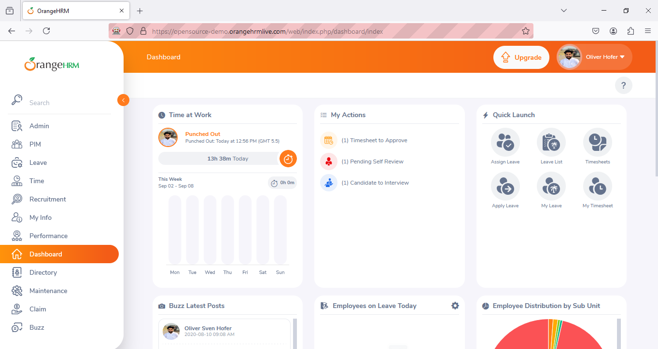

**3) PathSelector**

|  |
| --- |
| package JavaPracticals;  import org.openqa.selenium.By;  import org.openqa.selenium.WebDriver;  import org.openqa.selenium.firefox.FirefoxDriver; // Using Firefox driver  public class pathselector {  public static void main(String[] args) throws Exception {    // Set the system property for GeckoDriver (used by Firefox)  System.setProperty(  "webdriver.gecko.driver",  "C:\\selenium web driver\\ChromeDriver\\chromedriver-win64\\chromedriver-win64\\geckodriver.exe"  );  // Initialize the Firefox WebDriver  WebDriver wd = new FirefoxDriver();  // Open the OrangeHRM login page  wd.get("https://opensource-demo.orangehrmlive.com/");  // Wait for 2 seconds to ensure page loads  Thread.sleep(2000);  // Enter username in the username input field  wd.findElement(By.xpath("//*[@id='app']/div[1]/div/div[1]/div/div[2]/div[2]/form/div[1]/div/div[2]/input"))  .sendKeys("admin");  // Enter password in the password input field  wd.findElement(By.xpath("//*[@id='app']/div[1]/div/div[1]/div/div[2]/div[2]/form/div[2]/div/div[2]/input"))  .sendKeys("admin123");  // Click the login button  wd.findElement(By.xpath("//*[@id='app']/div[1]/div/div[1]/div/div[2]/div[2]/form/div[3]/button"))  .click();  }  } |

OUTPUT:



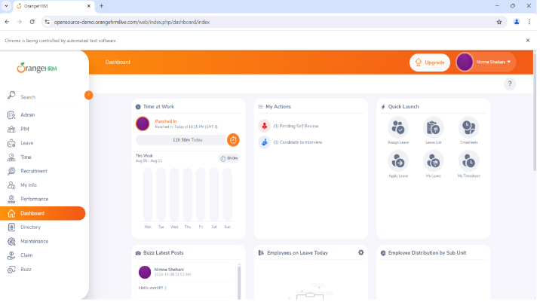

# PRACTICAL NO: 07

**Aim:** Demonstrate Synchronisation in Selenium (Implicity wait,Explicitly wait)

**1) Implicit wait**

|  |
| --- |
| Package JavaPracticals;  import java.util.concurrent.TimeUnit;  import org.openqa.selenium.By;  import org.openqa.selenium.WebDriver;  import org.openqa.selenium.firefox.FirefoxDriver;  public class Practical2 {  @SuppressWarnings("deprecation")  public static void main(String[] args) throws Exception {  System.setProperty(  "webdriver.gecko.driver",  "C:\\selenium web driver\\ChromeDriver\\chromedriver-win64\\chromedriver-win64\\geckodriver.exe"  );  WebDriver wd = new FirefoxDriver();  wd.get("https://opensource-demo.orangehrmlive.com/");  Thread.sleep(2000);  wd.findElement(By.name("username")).sendKeys("admin");  wd.findElement(By.name("password")).sendKeys("admin123");  wd.findElement(By.className("oxd-button")).click();  wd.close();  }  } |

OUTPUT:



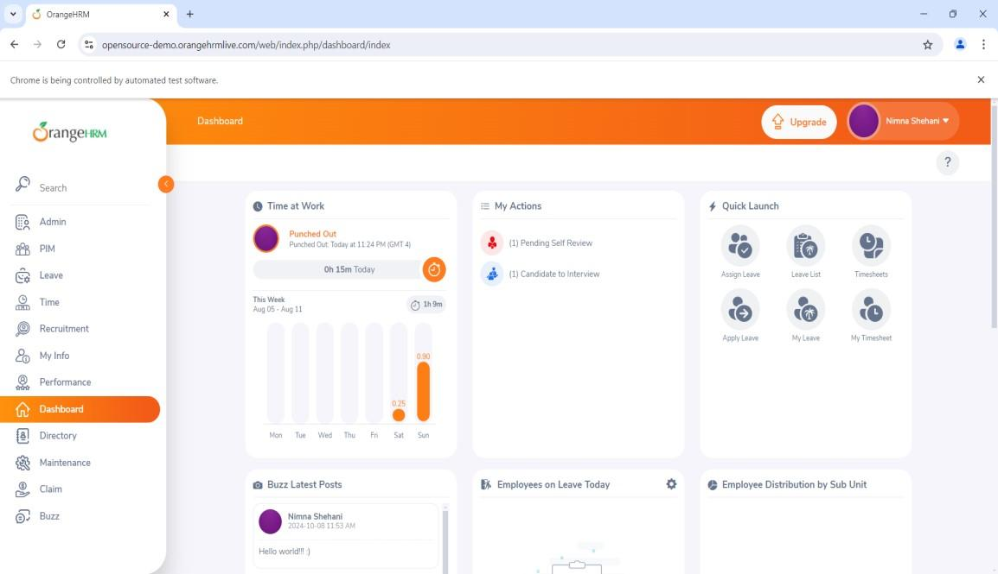

**2) Explicit wait**

|  |
| --- |
| package JavaPracticals;  import java.time.Duration;  import org.openqa.selenium.By;  import org.openqa.selenium.WebDriver;  import org.openqa.selenium.firefox.FirefoxDriver;  import org.openqa.selenium.support.ui.ExpectedConditions;  import org.openqa.selenium.support.ui.WebDriverWait;  public class Practical3 {  public static void main(String[] args) throws Exception {  System.setProperty(  "webdriver.gecko.driver",  "C:\\selenium web driver\\ChromeDriver\\chromedriver-win64\\chromedriver-win64\\geckodriver.exe"  );  WebDriver wd = new FirefoxDriver();  wd.get("https://opensource-demo.orangehrmlive.com/");  WebDriverWait wt = new WebDriverWait(wd, Duration.ofSeconds(30));  wt.until(ExpectedConditions.visibilityOfElementLocated(By.name("username"))).sendKeys("admin");  wt.until(ExpectedConditions.visibilityOfElementLocated(By.name("password"))).sendKeys("admin123");  wt.until(ExpectedConditions.visibilityOfElementLocated(By.className("oxd-button"))).click();  wt.until(ExpectedConditions.elementToBeClickable(By.className("oxd-userdropdown-tab"))).click();  Thread.sleep(5000);  wt.until(ExpectedConditions.elementToBeClickable(By.partialLinkText("Logout"))).click();  }  } |

OUTPUT:

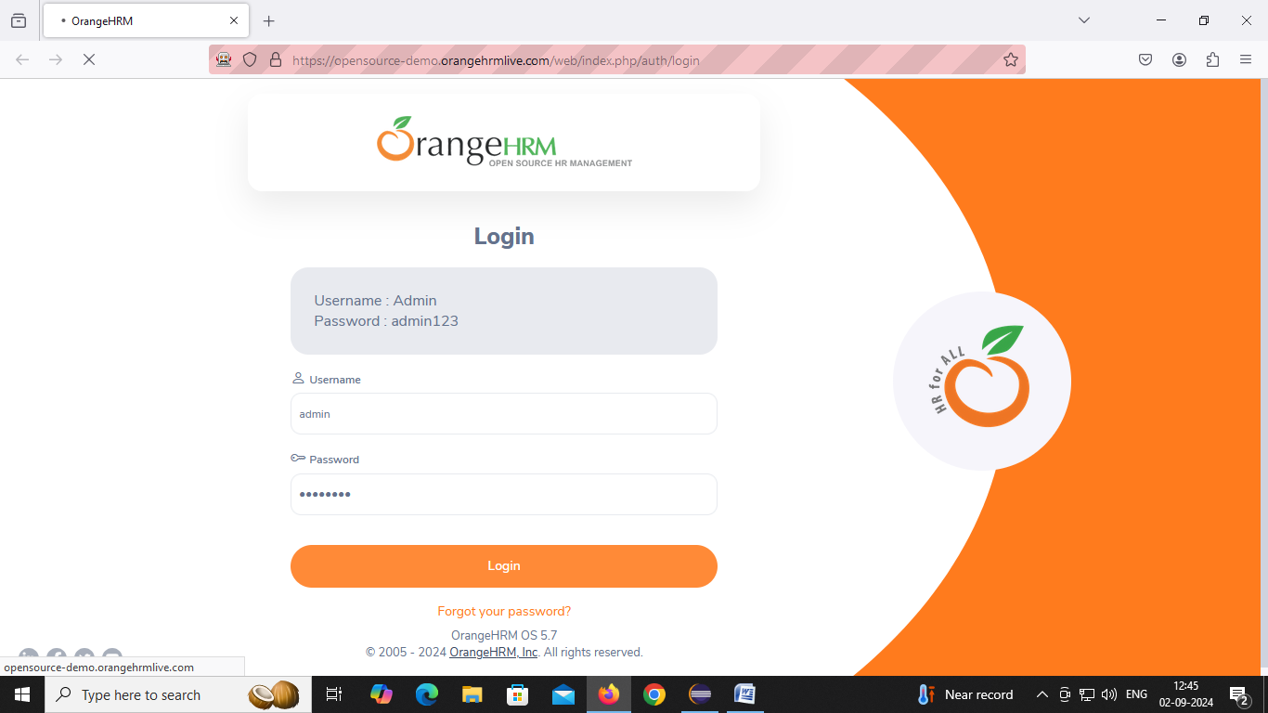

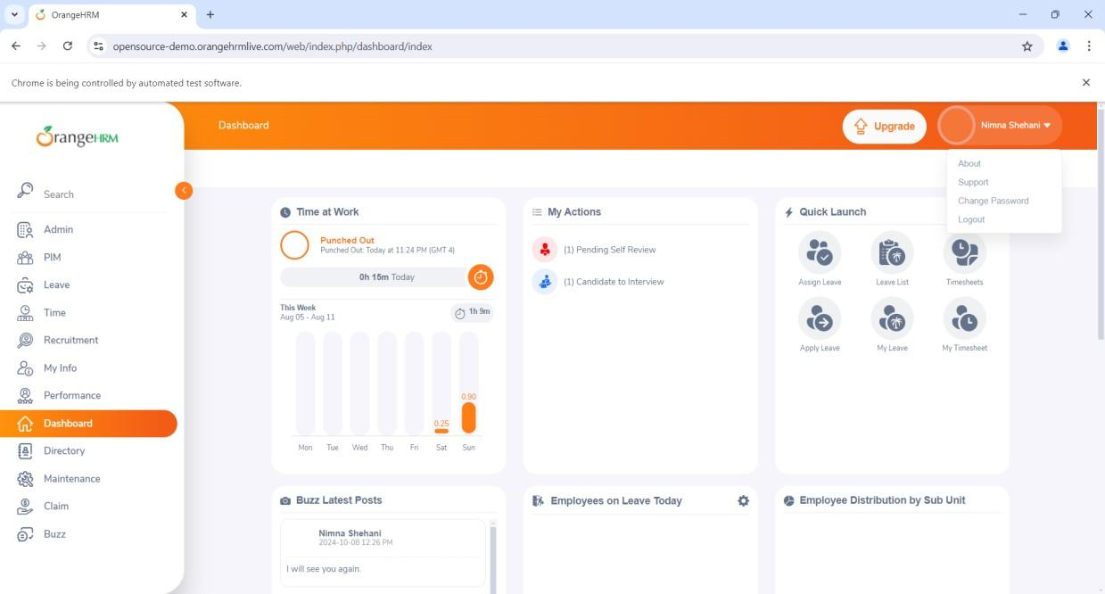

# PRACTICAL NO: 08

**Aim:** Demonstrate Different types of alerts.

|  |
| --- |
| package JavaPracticals;  import org.openqa.selenium.By;  import org.openqa.selenium.WebDriver;  importorg.openqa.selenium.chrome.ChromeDriver;  import org.openqa.selenium.firefox.FirefoxDriver;  import org.openqa.selenium.support.ui.Select;  publicclass alert {  Public static void main(String[] args)  {  System.setProperty("webdriver.chrome.driver","C:\\selenium web driver\\ChromeDriver\\chromedriver-win64\\chromedriver-win64\\geckodriver.exe");  WebDriver wd = new FirefoxDriver();  wd.get("https://demo.frontaccounting.eu/");  wd.findElement(By.name("user_name_entry_field")).sendKeys("");  wd.findElement(By.name("password")).sendKeys("");  Select s = new Select(wd.findElement(By.name("company_login_name")));  wd.findElement(By.name("SubmitUser")).click();  wd.findElement(By.xpath("/html/body/table[1]/tbody/tr/td/table[1]/tbody/tr/td/div[2]/table/tbody/tr[1]/t d/table/tbody/tr[2]/td[1]/a[1]")).click();  String Pid = wd.getWindowHandle();//getting id of current page  System.out.println("Parent Window > " + Pid);  Select s1 = new Select(wd.findElement(By.name("customer_id")));  s1.selectByVisibleText("Donald Easter");  wd.findElement(By.name("CancelOrder")).click();  }  } |

OUTPUT:

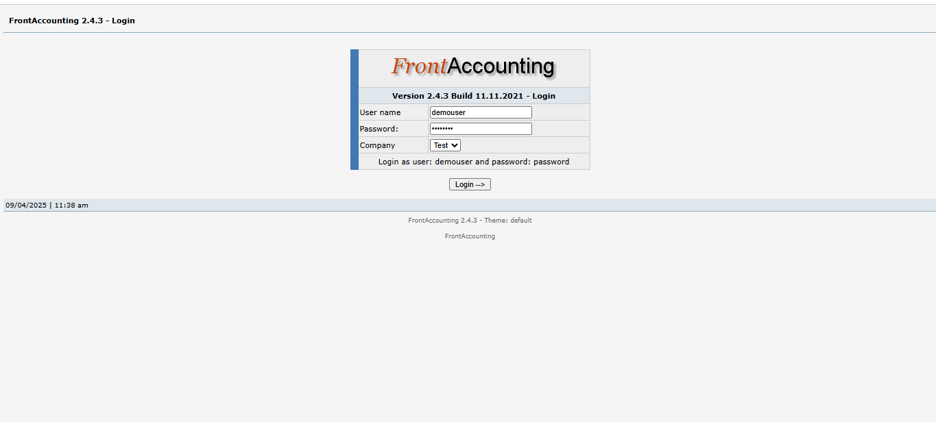

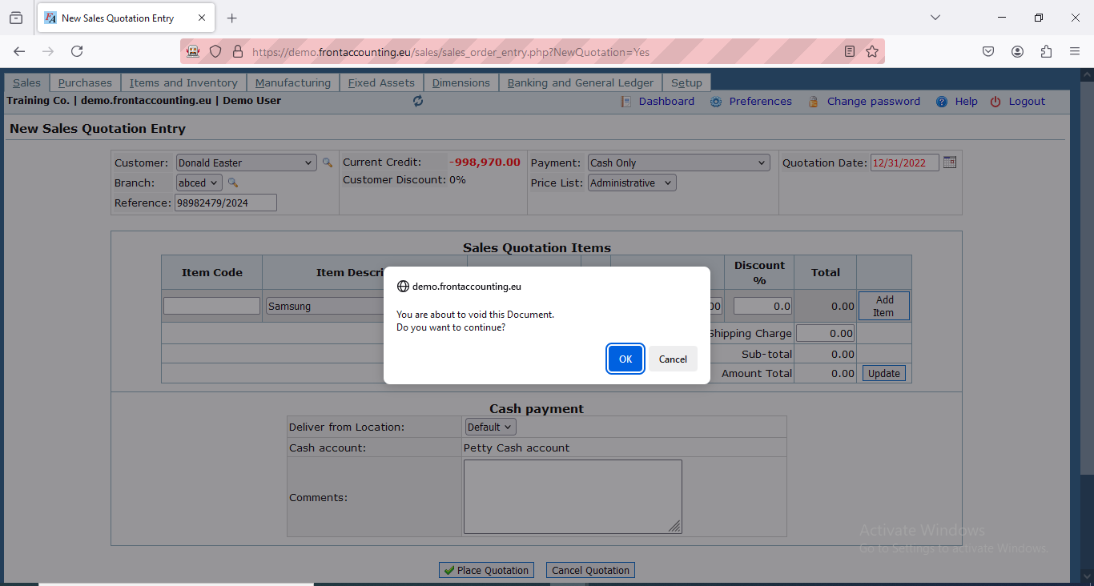

# PRACTICAL NO: 09

**Aim:** Demonstrate Multi Window Handling.

|  |
| --- |
| package JavaPracticals;  import java.util.Set;  import org.openqa.selenium.By;  import org.openqa.selenium.WebDriver;  import org.openqa.selenium.firefox.FirefoxDriver;  import org.openqa.selenium.support.ui.Select;  public class MultipleWindowHandling {  public static void main(String[] args) {  //Set the path for GeckoDriver (since you're using Firefox)  System.setProperty("webdriver.gecko.driver",  "C:\\selenium web driver\\ChromeDriver\\chromedriver-win64\\geckodriver.exe");  WebDriver wd = new FirefoxDriver();  // Open FrontAccounting demo site  wd.get("https://demo.frontaccounting.eu/");  // Login  wd.findElement(By.name("user_name_entry_field")).sendKeys("your_username"); // Replace with valid username  wd.findElement(By.name("password")).sendKeys("your_password"); // Replace with valid password  // Select company (if required)  Select s = new Select(wd.findElement(By.name("company_login_name")));  // s.selectByVisibleText("Default Company"); // Uncomment if needed  wd.findElement(By.name("SubmitUser")).click();  // Click link to open a new window  wd.findElement(By.xpath( "/html/body/table[1]/tbody/tr/td/table[1]/tbody/tr/td/div[2]/table/tbody/tr[1]/td/table/tbody/tr[2]/td[1]/a"  )).click();  // Get parent window ID  String parentId = wd.getWindowHandle();  System.out.println("Parent Window: " + parentId);  // Click a link that opens another window  wd.findElement(By.xpath(  "/html/body/table[1]/tbody/tr/td/table[1]/tbody/tr/td/div[2]/form/center[1]/table/tbody/tr/td[2]/table/tbody/tr[1]/td[2]/a"  )).click();  // Handle all window IDs  Set<String> allWindows = wd.getWindowHandles();  for (String windowId : allWindows) {  wd.switchTo().window(windowId);  System.out.println("Window Title: " + wd.getTitle());  if (!windowId.equals(parentId)) {  // Perform actions in the new window  Select ss = new Select(wd.findElement(By.id("customer_id"))); // Ensure ID is correct  ss.selectByVisibleText("Donald Easter");  wd.manage().window().maximize();  wd.close(); // Close the child window after work  }  }  // Switch back to parent window  wd.switchTo().window(parentId);  // Logout  wd.findElement(By.linkText("Logout")).click();  // Close browser  wd.quit();  }  } |

OUTPUT:

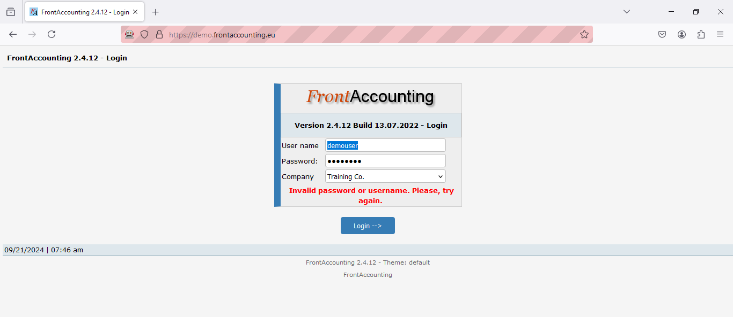

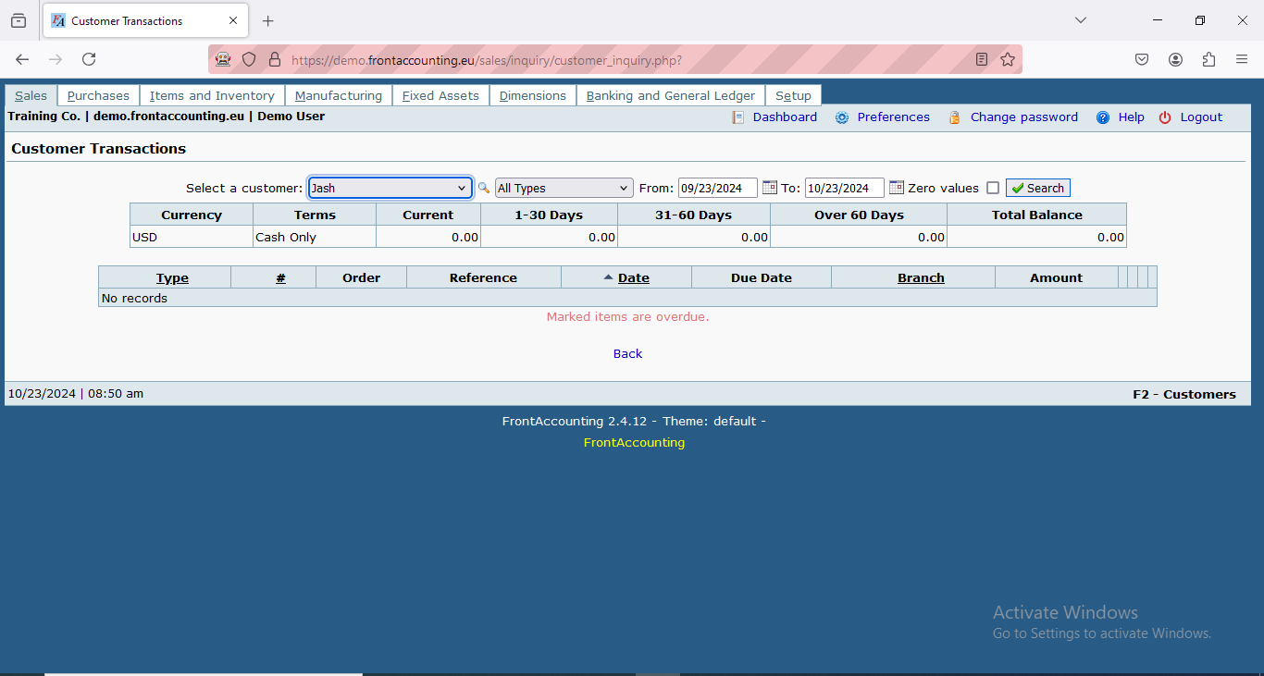

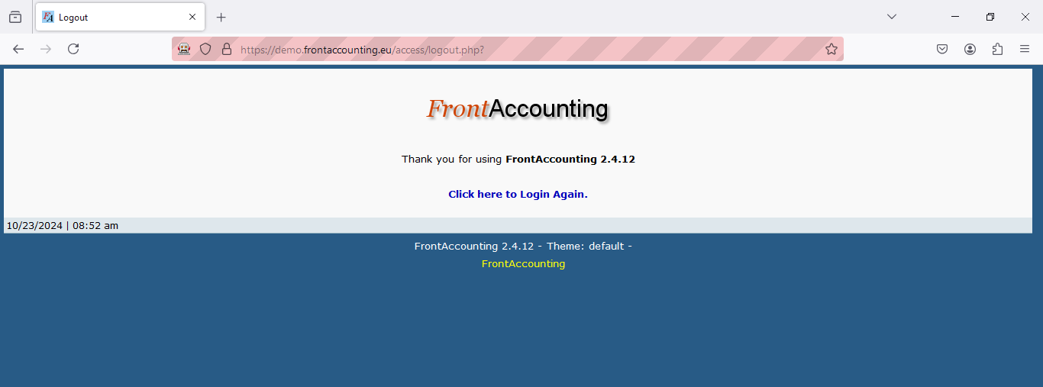

# PRACTICAL NO: 10

**Aim:** Demonstrate TestNG

**A) Demo DataProvider**

|  |
| --- |
| package testNG;  import org.testng.annotations.DataProvider;  import org.testng.annotations.Test;  public class Pract12 {  @Test(dataProvider = "dp")  public void f(Integer n, String s) {  System.out.println(n + " " + s);  }  @DataProvider  public Object[][] dp() {  return new Object[][]{  new Object[]{1, "A"},  new Object[]{2, "B"},  new Object[]{3, "C"},  new Object[]{4, "ajay"},  };  }  } |

OUTPUT:

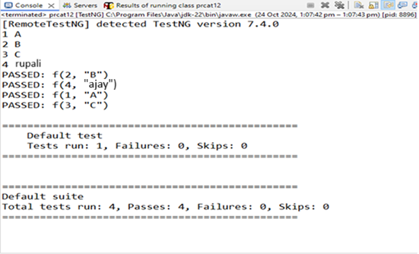

**B) Demo Annotation**

|  |
| --- |
| package testNG;  import org.testng.annotations.Test;  import org.testng.annotations.BeforeMethod;  import org.testng.annotations.AfterMethod;  import org.testng.annotations.BeforeClass;  import org.testng.annotations.AfterClass;  import org.testng.annotations.BeforeTest;  import org.testng.annotations.AfterTest;  import org.testng.annotations.BeforeSuite;  import org.testng.annotations.AfterSuite;  public class Pract12B {  @Test  public void f() {  System.out.println("Roll no: 111");  }  @BeforeMethod  public void beforeMethod() {  System.out.println("Before Method");  }  @AfterMethod  public void afterMethod() {  System.out.println("After Method");  }  @BeforeClass  public void beforeClass() {  System.out.println("Before Class");  }  @AfterClass  public void afterClass() {  System.out.println("After Class");  }  @BeforeTest  public void beforeTest() {  System.out.println("Before Test");  }  @AfterTest  public void afterTest() {  System.out.println("After Test");  }  @BeforeSuite  public void beforeSuite() {  System.out.println("Before Suite");  }  @AfterSuite  public void afterSuite() {  System.out.println("After Suite");  }  } |

OUTPUT:

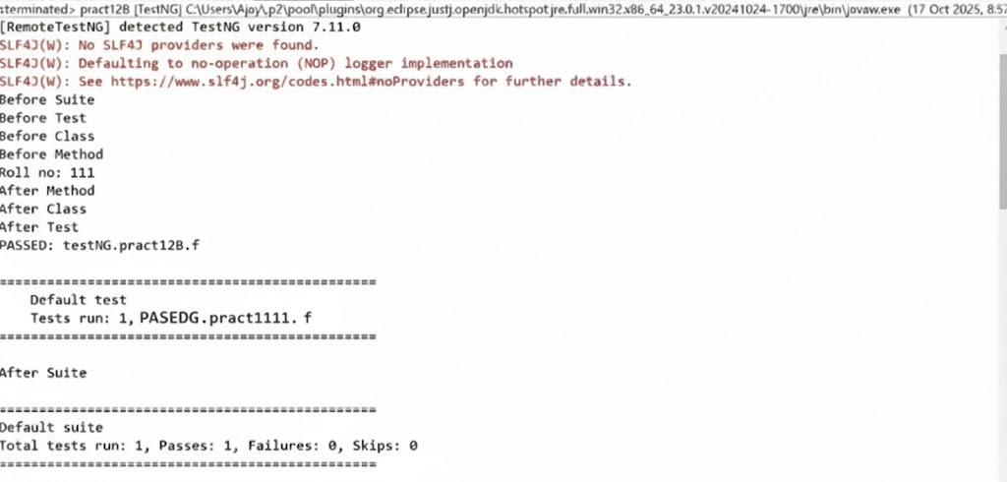

**C) Data OHM**

|  |
| --- |
| package testNG;  import java.util.concurrent.TimeUnit;  import org.openqa.selenium.By;  import org.openqa.selenium.WebDriver;  import org.openqa.selenium.firefox.FirefoxDriver;  import org.testng.annotations.Test;  import org.testng.annotations.DataProvider;  public class pracat12C {  @Test(dataProvider = "dp")  public void f(String u, String p) {  System.setProperty("webdriver.gecko.driver",  "C:\\selenium web driver\\ChromeDriver\\chromedriver-win64\\chromedriver-win64\\geckodriver.exe");  WebDriver wd = new FirefoxDriver();  wd.get("https://opensource-demo.orangehrmlive.com/");  wd.manage().timeouts().implicitlyWait(10, TimeUnit.SECONDS);  wd.findElement(By.name("username")).sendKeys(u); // locator name  wd.findElement(By.name("password")).sendKeys(p); // locator name  wd.findElement(By.className("oxd-button")).click();  try {  wd.findElement(By.className("oxd-userdropdown-name")).click();  wd.findElement(By.className("oxd-userdropdown-link")).click();  System.out.println("Pass");  } catch (Exception e) {  System.out.println("Fail");  } finally {  wd.quit();  }  }  @DataProvider  public Object[][] dp() {  return new Object[][] {  { "Admin", "admin123" },  { "add", "b" }  };  }  } |

OUTPUT:

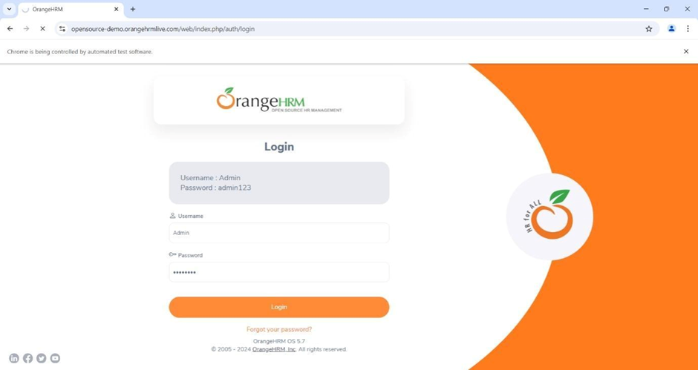

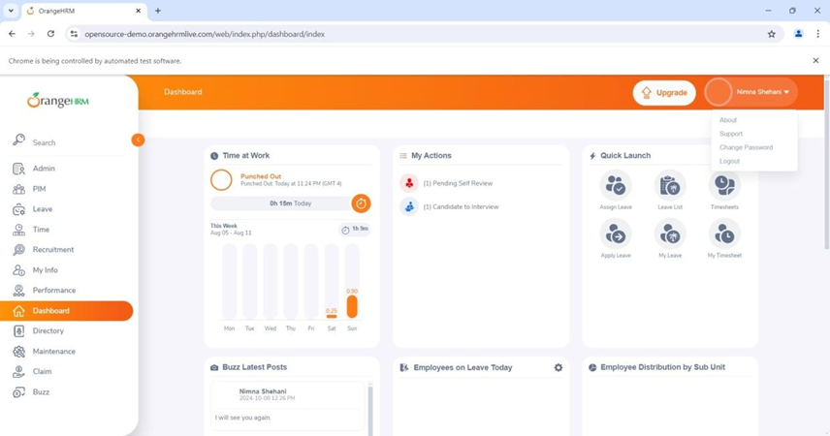

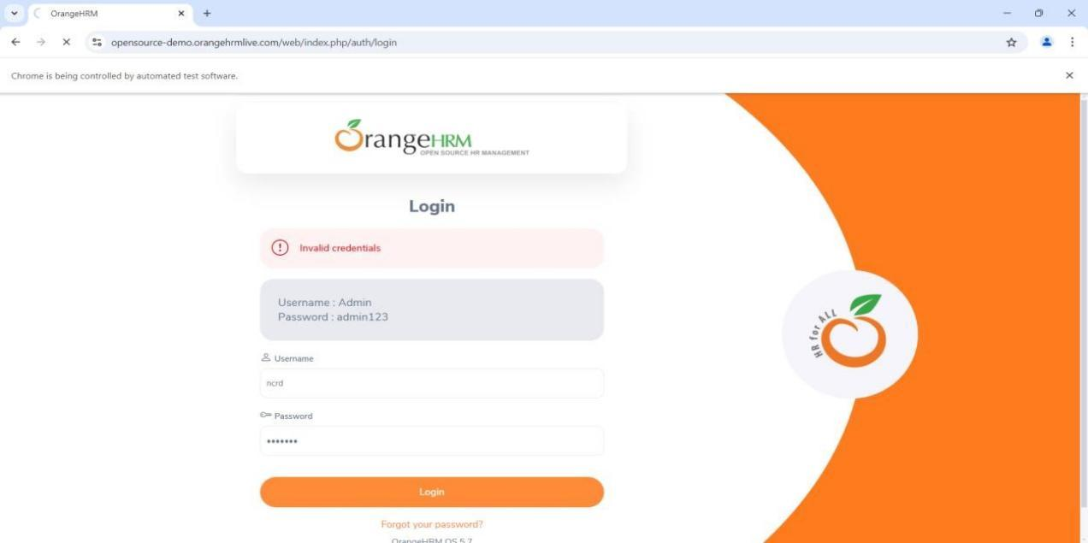

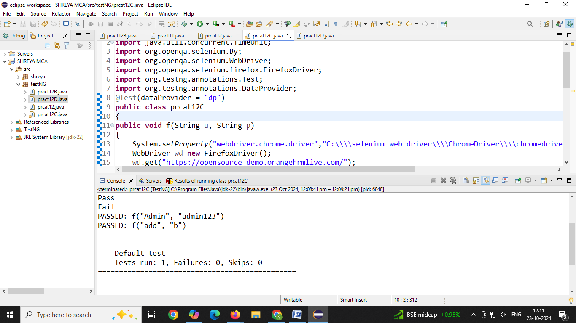

**D) DataCheck**

|  |
| --- |
| package testNG;  import org.openqa.selenium.By;  import org.openqa.selenium.WebDriver;  import org.openqa.selenium.firefox.FirefoxDriver;  import org.testng.Assert;  import org.testng.annotations.Test;  public class pract12D {  @Test(description = "Checking status of checkbox")  public void CheckBox() {  System.setProperty("webdriver.gecko.driver",  "C:\\selenium web driver\\ChromeDriver\\chromedriver-win64\\chromedriver-win64\\geckodriver.exe");  WebDriver wd = new FirefoxDriver();  wd.get("https://mail.rediff.com/cgi-bin/login.cgi");  Boolean sts = wd.findElement(By.name("remember")).isSelected();  Assert.assertTrue(sts, "Checkbox is not selected!");  wd.quit();  }  } |

OUTPUT:

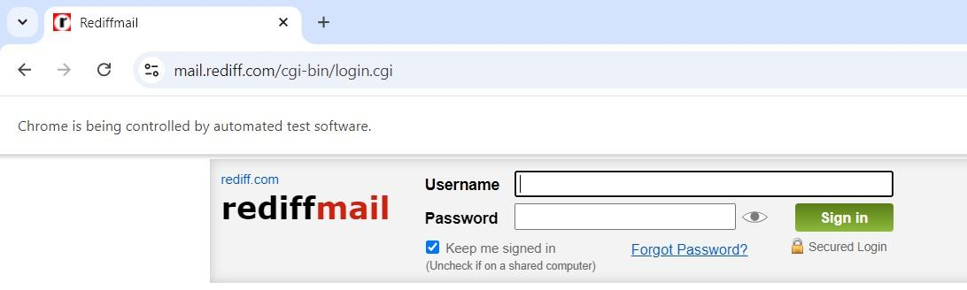

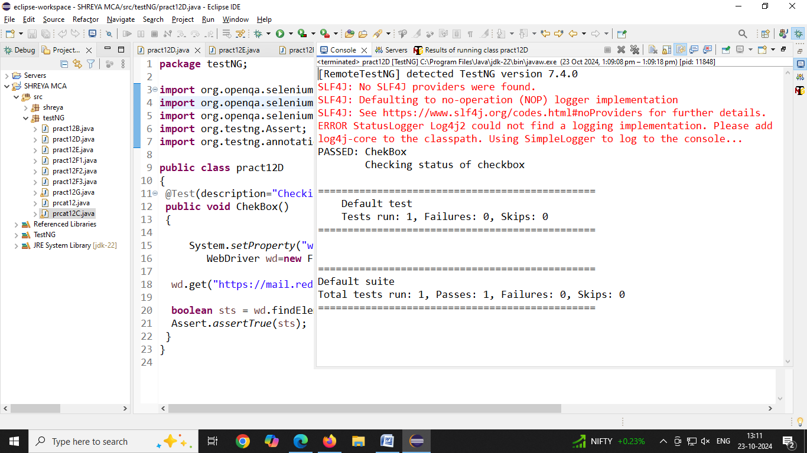

**E) DemoAssertFA**

|  |
| --- |
| package testNG;  import org.openqa.selenium.WebDriver;  import org.openqa.selenium.firefox.FirefoxDriver;  import org.testng.Assert;  import org.testng.annotations.Test;  public class pract12E {  @Test  public void frontAccounting() {  System.setProperty("webdriver.gecko.driver",  "C:\\selenium web driver\\ChromeDriver\\chromedriver-win64\\chromedriver-win64\\geckodriver.exe");  WebDriver wd = new FirefoxDriver();  wd.get("https://demo.frontaccounting.eu/index.php");  String expectedTitle = "FrontAccounting 2.4.12 - Login"; // if title is not matching, execution will fail  String actualTitle = wd.getTitle();  Assert.assertEquals(actualTitle, expectedTitle, "Title does not match!");  System.out.println("Title of Webpage =====> " + actualTitle);  wd.quit();  }} |

OUTPUT:

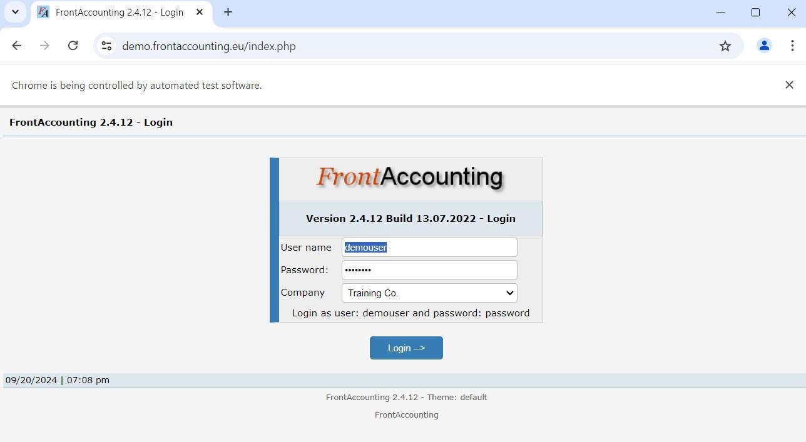

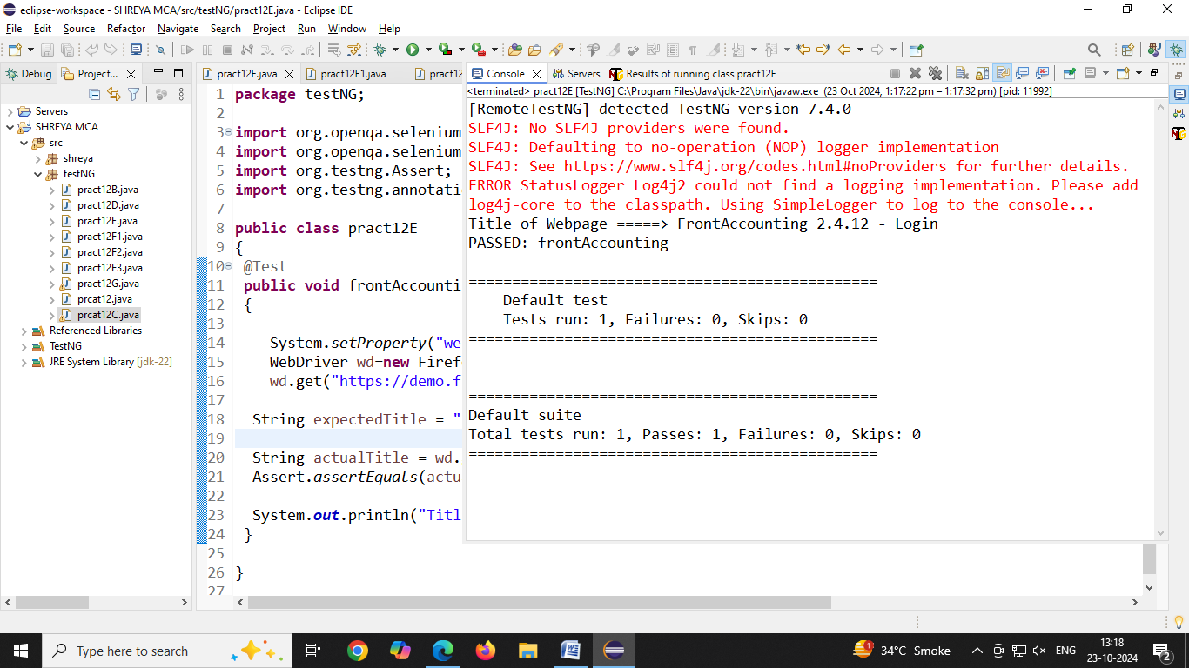

**F) DemoAlert**

**1)Alertbox**

|  |
| --- |
| package testNG;  import org.openqa.selenium.Alert;  import org.openqa.selenium.By;  import org.openqa.selenium.WebDriver;  import org.openqa.selenium.firefox.FirefoxDriver;  public class pract12F1 {  public static void main(String[] args) throws Exception {  System.setProperty("webdriver.gecko.driver",  "C:\\selenium web driver\\ChromeDriver\\chromedriver-win64\\chromedriver-win64\\geckodriver.exe");  WebDriver wd = new FirefoxDriver();  wd.get("https://vinothqaacademy.com/alert-and-popup/");  wd.findElement(By.name("alertbox")).click();  Thread.sleep(2000);  Alert alt = wd.switchTo().alert();  System.out.println("Text of Alert: " + alt.getText()); // capture alert text  alt.accept(); // click on OK button  wd.quit();  }  } |

OUTPUT:

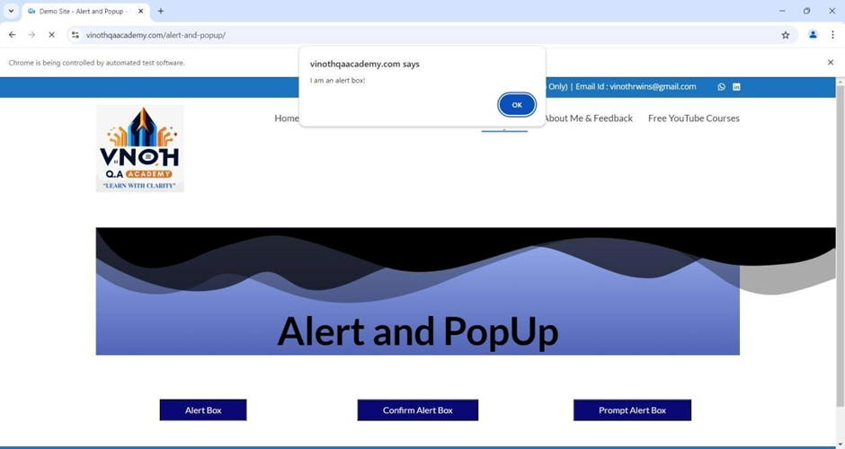

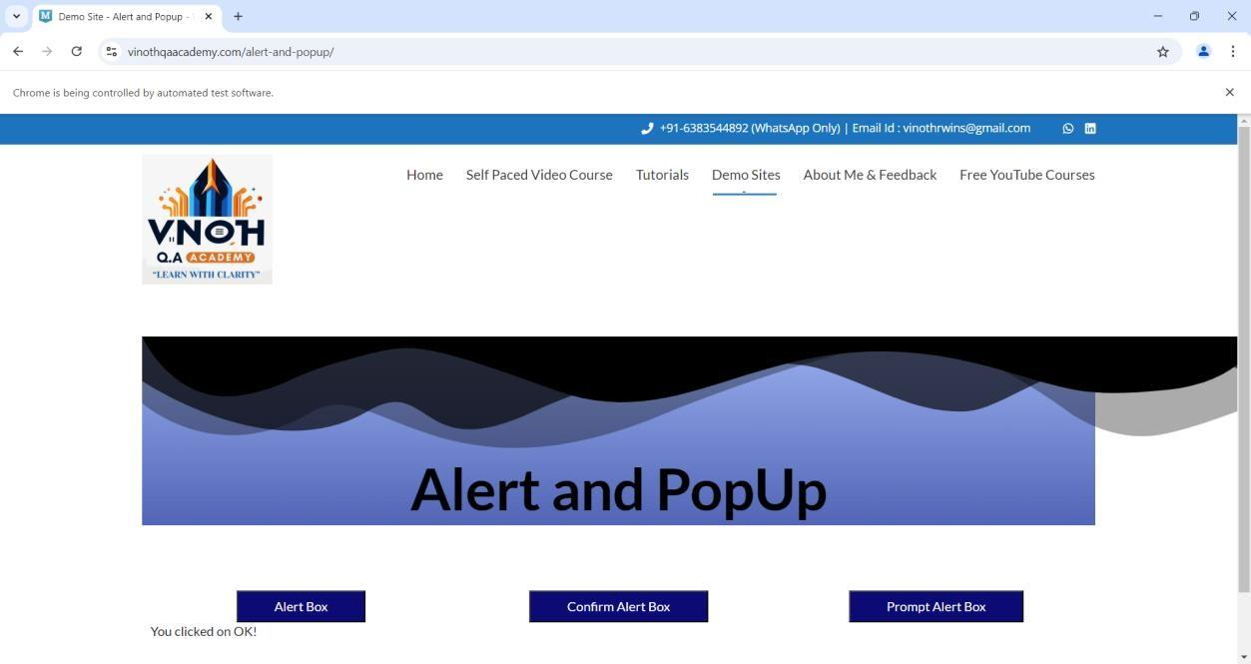

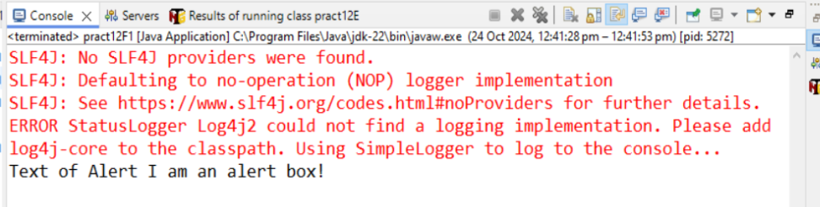

**G) TestNG using xml**

|  |
| --- |
| package testNG;  import utilities.ReadPropertyFiIe; import java.io.IOException; import java.utiI.Properties; import org.openqa.selenium.By;  import org.openqa.selenium.WebDriver;  import org.openqa.selenium.chrome.ChromeDriver; import io.github.bonigarcia.wdm.WebDriverManager;  public class MyFirstTest (  public static void main(String[] args) throws IOException, InterruptedException { Properties prop = ReadPropertyFiIe.getProperties();  String browser = prop.getProperty("browser"); String url = prop.getProperty("testurI");  if (browser.equaIsIgnoreCase("chrome")) { WebDriverManager.chromedriver().setup(); WebDriver driver = new ChromeDriver();  to ( driver.manage().window().maximize(); driver.get(url);  System.out.printIn("Opened URL: " + url);  *I/* Example locators (update according to the real page)  *l/* driver.findEIement(By.IinkText("Sign in")).click();  *l/* driver.findEIement(By.id("login id")).sendKeys(prop.getProperty("login id"));  *l/* driver.findEIement(By.id("password")).sendKeys(prop.getProperty("password"));  *l/* driver.findEIement(By.xpath("//button[@id=’nextbtn’]")).click();  Thread.sleep(3000);  } finally { driver.quit();  ) else {  System.out.printIn("Browser not supported: " + browser); |

OUTPUT:

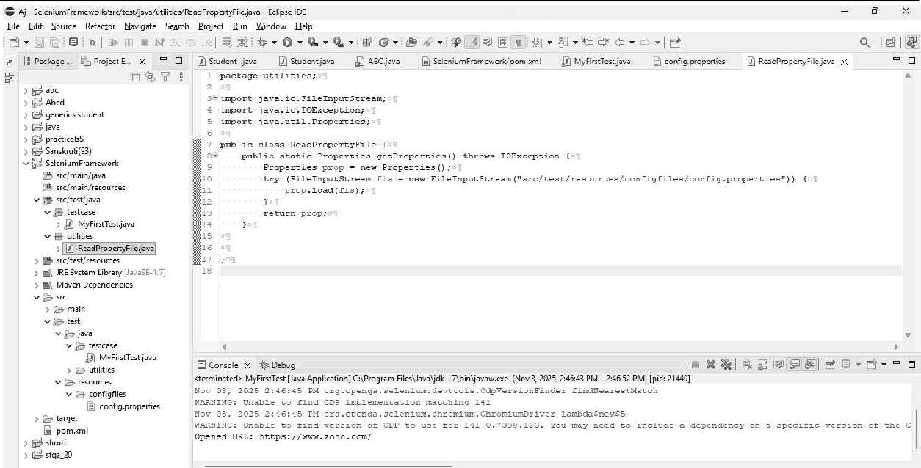

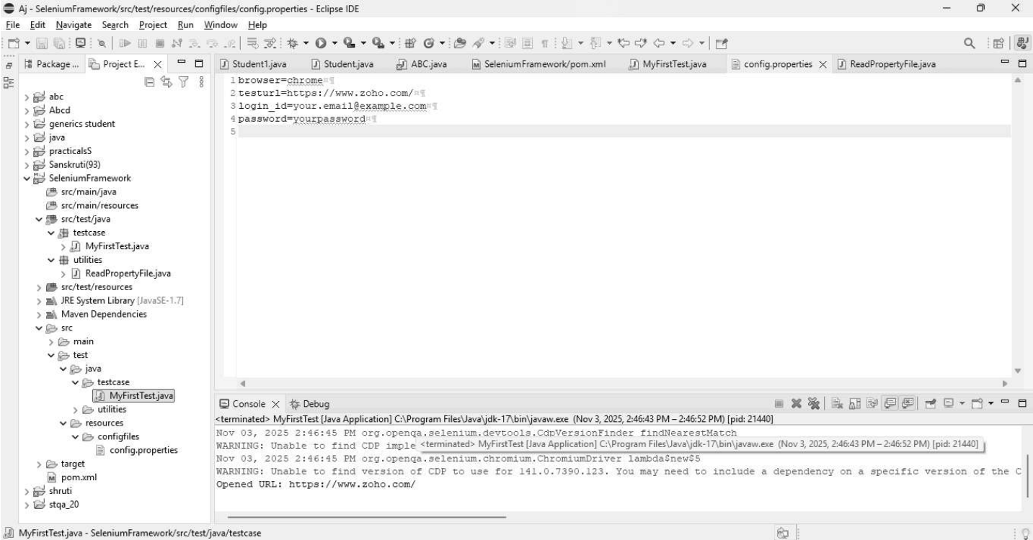

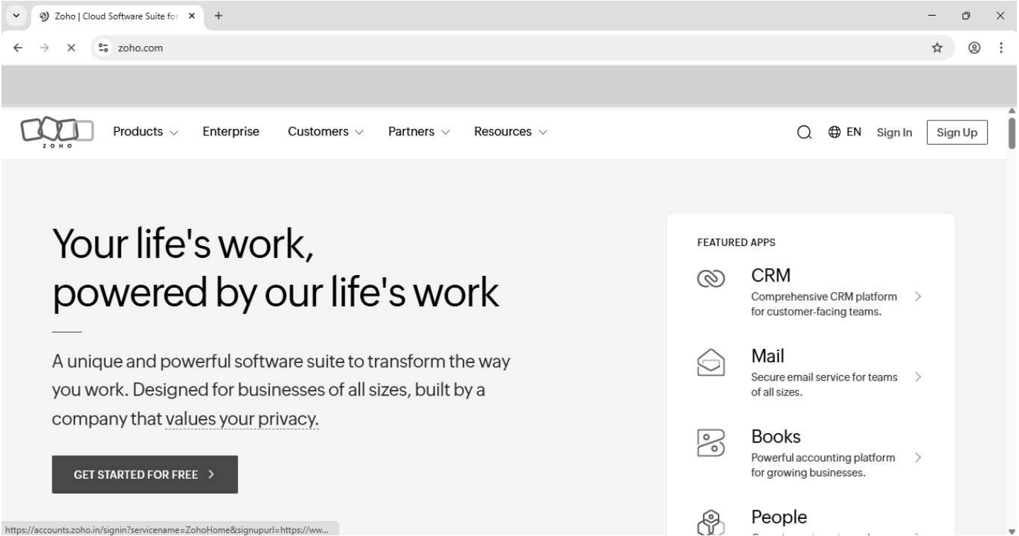

# PRACTICAL NO: 11

**Aim:** Demonstrate data driven Framework

**1) File read data from Excel and perform testing using selenium.**

|  |
| --- |
| package JavaPracticals;  import java.io.FileInputStream;  import java.io.IOException;  import org.apache.poi.xssf.usermodel.XSSFCell;  import org.apache.poi.xssf.usermodel.XSSFRow;  import org.apache.poi.xssf.usermodel.XSSFSheet;  import org.apache.poi.xssf.usermodel.XSSFWorkbook;  // Get Data From Excel  public class Eighth_1 {  public static void main(String[] args) throws IOException {  FileInputStream fis = new FileInputStream("D:\\STQA\\Excel1.xlsx");  XSSFWorkbook wb = new XSSFWorkbook(fis);  XSSFSheet sh = wb.getSheet("Sheet1");  for (int i = 1; i <= sh.getLastRowNum(); i++) {  XSSFRow rw = sh.getRow(i);  XSSFCell un = rw.getCell(0);  XSSFCell pw = rw.getCell(1);  XSSFCell rs = rw.getCell(2);  System.out.println("Username ---> " + un + " Password ---> " + pw + " Result ---> " + rs);  }  wb.close();  fis.close();  }  } |

OUTPUT:

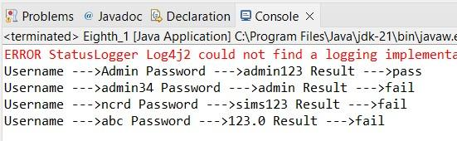

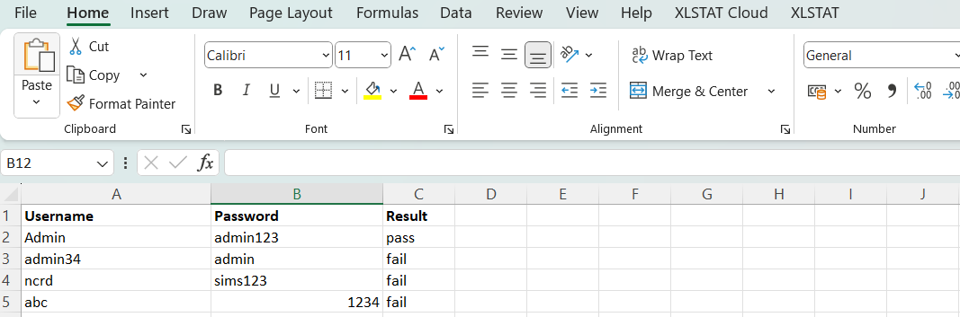





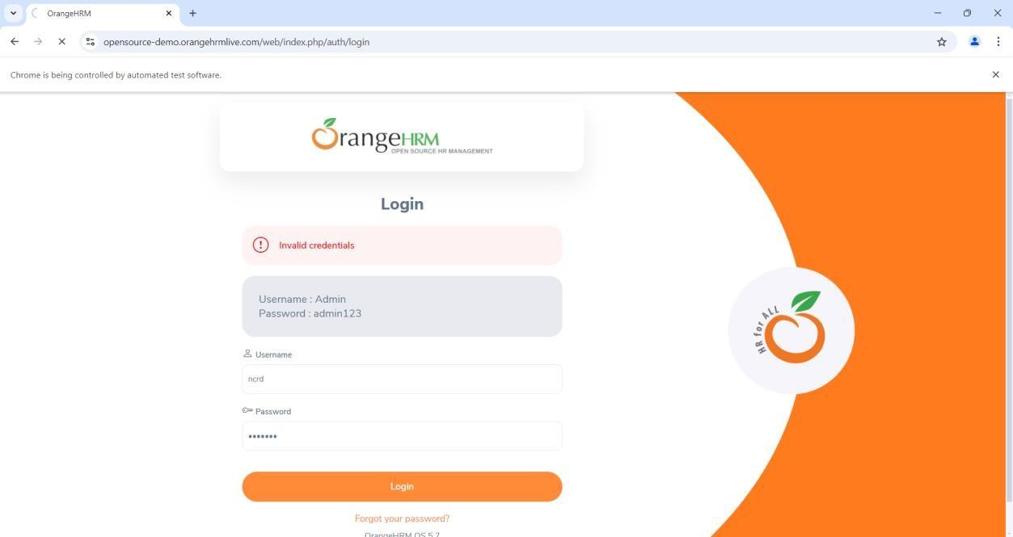

# PRACTICAL NO: 12

**Aim:** Write a Program to Read data from an Excel file and login in to site.

|  |
| --- |
| package JavaPracticals;  import java.io.FileInputStream;  import java.io.FileOutputStream;  import java.io.IOException;  import java.util.concurrent.TimeUnit;  import org.apache.poi.xssf.usermodel.XSSFCell;  import org.apache.poi.xssf.usermodel.XSSFRow;  import org.apache.poi.xssf.usermodel.XSSFSheet;  import org.apache.poi.xssf.usermodel.XSSFWorkbook;  import org.openqa.selenium.By;  import org.openqa.selenium.WebDriver;  import org.openqa.selenium.chrome.ChromeDriver;  public class Eighth_3 {  public static void main(String[] args) throws IOException {  System.setProperty("webdriver.chrome.driver",  "D:\\STQA\\Selenium\\chromedriverwin64\\chromedriver.exe");  WebDriver wd = new ChromeDriver();  wd.manage().timeouts().implicitlyWait(10, TimeUnit.SECONDS);  wd.get("https://opensource-demo.orangehrmlive.com/");  FileInputStream fis = new FileInputStream("D:\\STQA\\Excel1.xlsx");  XSSFWorkbook wb = new XSSFWorkbook(fis);  XSSFSheet sh = wb.getSheet("WriteData");  for (int i = 1; i <= sh.getLastRowNum(); i++) {  XSSFRow rw = sh.getRow(i);  XSSFCell un = rw.getCell(0);  XSSFCell pw = rw.getCell(1);  XSSFCell res = rw.createCell(2);  System.out.println("Username --> " + un + " | Password --> " + pw);  wd.findElement(By.name("username")).clear();  wd.findElement(By.name("username")).sendKeys(un.toString());  wd.findElement(By.name("password")).clear();  wd.findElement(By.name("password")).sendKeys(pw.toString());  wd.findElement(By.className("oxd-button")).click();  try {  wd.findElement(By.className("oxd-userdropdown-name")).click();  wd.findElement(By.partialLinkText("Logout")).click();  System.out.println("Login Pass");  res.setCellValue("Valid");  } catch (Exception e) {  System.out.println("Login Fail");  res.setCellValue("Invalid");  }  }  FileOutputStream fos = new FileOutputStream("D:\\STQA\\ExcelData_1.xlsx");  wb.write(fos);  fos.close();  fis.close();  wb.close();  wd.quit();  System.out.println("Test completed and results written to Excel file.");  }  } |

OUTPUT:



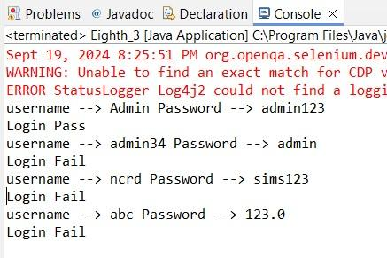



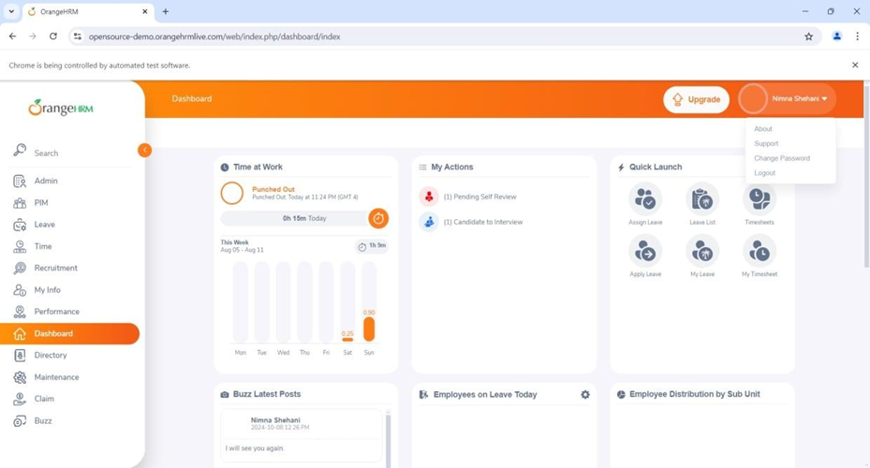

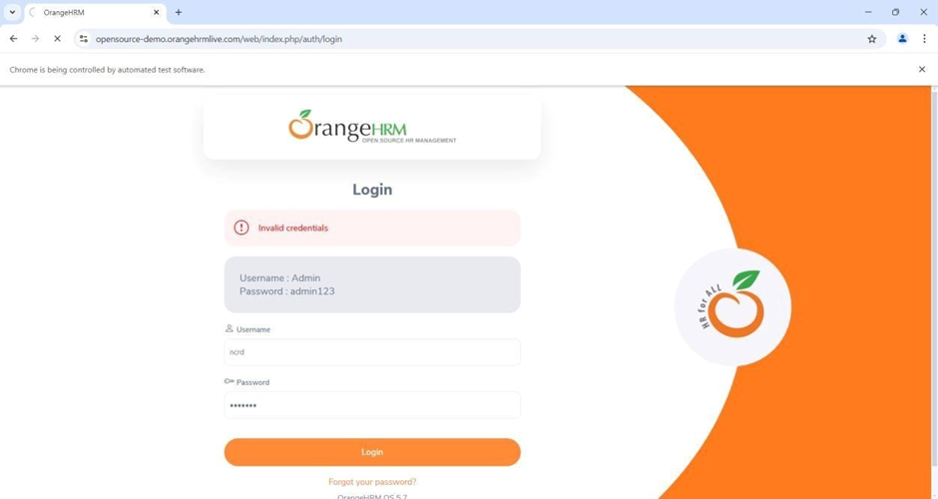

# PRACTICAL NO: 13

**Aim:** Validation Testing using Chrome and Bing.

**A) Chrome**

|  |
| --- |
| Package JavaPracticals;  import org.openqa.selenium.By;  import org.openqa.selenium.Keys;  import org.openqa.selenium.WebDriver;  import org.openqa.selenium.firefox.FirefoxDriver;  public class Practical8 {  public static void main(String[] args) throws Exception {  System.setProperty("webdriver.gecko.driver", "C:\\Selenium webdriver\\geckodriver\\geckodriver.exe");  WebDriver wd = new FirefoxDriver();  wd.get("https://google.com/");  // wd.get("https://bing.com/");  Thread.sleep(2000);  // For Firefox  wd.findElement(By.className("gLFyf")).sendKeys("Fruits");  wd.findElement(By.className("gLFyf")).sendKeys(Keys.ENTER);  }  } |

OUTPUT:

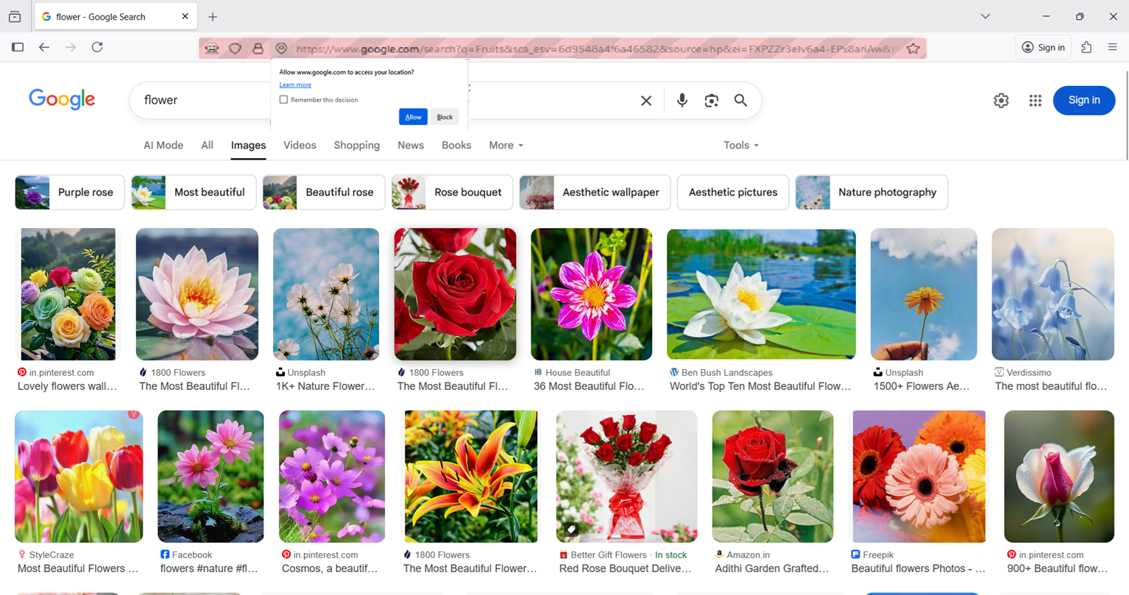

**B)Bing**

|  |
| --- |
| package JavaPracticals;  import org.openqa.selenium.By;  import org.openqa.selenium.Keys;  import org.openqa.selenium.WebDriver;  import org.openqa.selenium.firefox.FirefoxDriver;  public class Practical8 {  public static void main(String[] args) throws Exception {  System.setProperty("webdriver.gecko.driver", "C:\\Selenium webdriver\\geckodriver\\geckodriver.exe");  WebDriver wd = new FirefoxDriver();  wd.get("https://google.com/");  // wd.get("https://bing.com/");  Thread.sleep(2000);  // For Firefox (Google)  // wd.findElement(By.className("gLFyf")).sendKeys("Fruits");  // wd.findElement(By.className("gLFyf")).sendKeys(Keys.ENTER);  // For Bing  wd.findElement(By.className("sb_form_q")).sendKeys("Fruits");  wd.findElement(By.className("sb_form_q")).sendKeys(Keys.ENTER);  }  } |

OUTPUT:

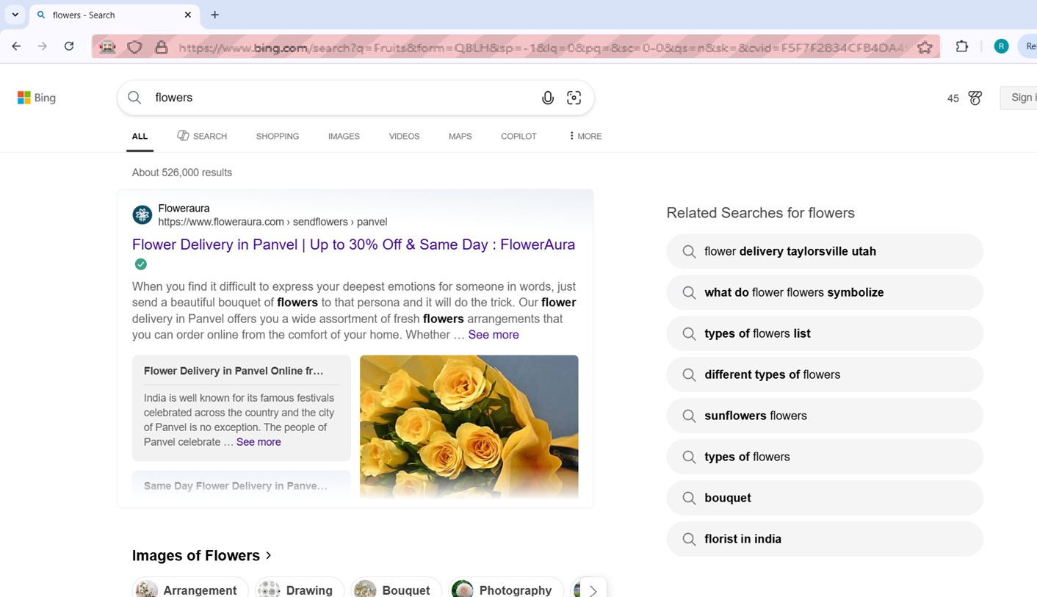

# PRACTICAL NO: 14

**Aim:** Demonstrate Library Architecture Framework.

|  |
| --- |
| package testcases;  import library.AppLibrary;  import utils.ExcelLibrary;  public class TestExecution {  public static void main(String[] args) throws Exception {  String excelPath = "C:\\Users\\Asus\\Downloads\\ExcelData.xlsx";  ExcelLibrary excel = new ExcelLibrary(excelPath, "Sheet1");  AppLibrary app = new AppLibrary();  System.out.println("--- Starting Library Architecture Framework ---");  for (int i = 1; i <= excel.getRowCount(); i++) {  String username = excel.getCellData(i, 0);  String password = excel.getCellData(i, 1);  String expected = excel.getCellData(i, 2);  System.out.println("\nTesting User: " + username + " | Expected: " + expected);  app.launchBrowser();  app.openApplication();  String actualResult = app.performLogin(username, password);  System.out.println("Actual Result: " + actualResult);  excel.setCellData(i, 3, actualResult); // write result to Excel  app.closeBrowser();  }  excel.closeWorkbook();  System.out.println("--- Test Execution Completed ---");  }  } |

OUTPUT:

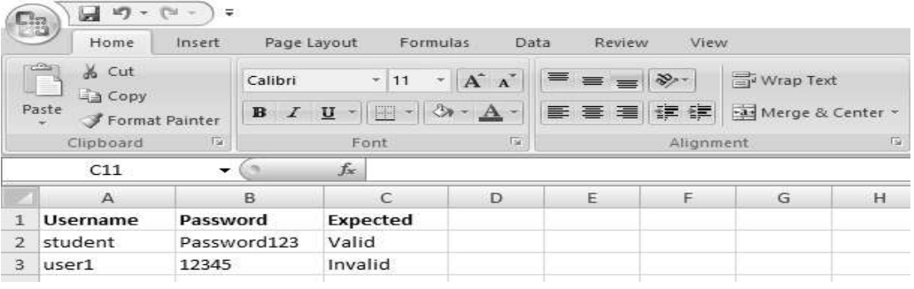

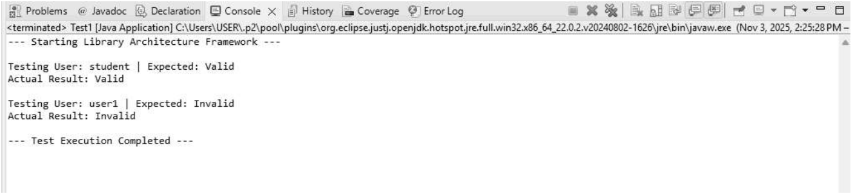

# PRACTICAL NO: 15

**Aim:** Perform Regression Testing.

***What is Regression Testing?***

REGRESSION TESTING is defined as a type of software testing to confirm that a recent program or code change has not adversely affected existing features. Regression Testing is nothing but a full or partial selection of already executed test cases which are re-executed to ensure existing functionalities work fine.This testing is done to make sure that new code changes should not have side effects on the existing functionalities. It ensures that the old code still works once the latest code changes are done.

***Need of Regression Testing***

The Need of Regression Testing mainly arises whenever there is requirement to change the code and we need to test whether the modified code affects the other part of software application or not. Moreover, regression testing is needed, when a new feature is added to the software application and for defect fixing as well as performance issue fixing.

***How to do Regression Testing***

In order to do Regression Testing process, we need to first debug the code to identify the bugs. Once the bugs are identified, required changes are made to fix it, then the regression testing is done by selecting relevant test cases from the test suite that covers both modified and affected parts of the code.

Software maintenance is an activity which includes enhancements, error corrections,optimization and deletion of existing features. These modifications may cause the system to work incorrectly. Therefore, Regression Testing becomes necessary.

***Regression Test Selection***

Regression Test Selection is a technique in which some selected test cases from test suite are executed to test whether the modified code affects the software application or not. Test cases are categorized into two parts, reusable test cases which can be used in further regression cycles and obsolete test cases which can not be used in succeeding cycles

**Calculator.java**

|  |
| --- |
| package regression;  public class Calculator {  public int add(int a, int b) {  return a + b;  }  public int subtract(int a, int b) {  return a - b;  }  public int multiply(int a, int b) {  return a * b;  }  } |

**RegressionTest.java**

|  |
| --- |
| package regression;  import org.testng.Assert;  import org.testng.annotations.Test;  public class RegressionTest {  Calculator calc = new Calculator();  @Test(priority = 1)  public void testAddition() {  Assert.assertEquals(calc.add(10, 5), 15);  System.out.println("Addition test passed!");  }  @Test(priority = 2)  public void testSubtraction() {  Assert.assertEquals(calc.subtract(10, 5), 5);  System.out.println("Subtraction test passed!");  }  // New test case added after modification  @Test(priority = 3)  public void testMultiplication() {  Assert.assertEquals(calc.multiply(10, 5), 50);  System.out.println("Multiplication test passed!");  }  } |

OUTPUT:

